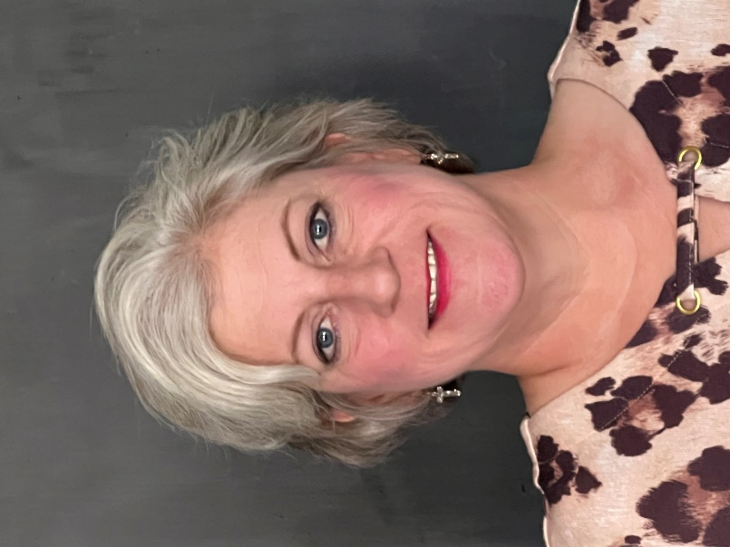
Dr. Misty Heiskell is a passionate educator with 23 years of experience in public education. Prior to coming to Channing ISD, Dr. Heiskell served as the campus principal for Dalhart Intermediate School for 8 years, an assistant principal for Canyon ISD for 2 years, and she was a classroom teacher for thirteen years.
Dr. Heiskell received her Doctorate in Education Leadership in December, 2021 through West Texas A&M’s inaugural doctoral program. She also earned her Master’s Degree in Education Leadership, Superintendent Certification, and her Bachelor’s Degree in Interdisciplinary Studies from West Texas A&M University.

Dr. Heiskell is an active member of Texas Elementary Principals and Supervisors Association and Texas Association of School Administrators. She and her husband Vernon have two daughters, Cortney
Dr. Misty Heiskell Youree and Brianna Stegall, and two grand-
Superintendent daughters, Hadlee Stegall and Harper Stegall.

Dr. Heiskell is excited to join the Channing ISD
family, and is dedicated to leading the Eagles to
Excellence. Soar Eagles, Soar!
E-mail: misty.heiskell@channingisd.net

Dr. Misty Heiskell is a passionate educator with 23 years of experience in public education. Prior to coming to Channing, Dr. Heiskell served as the campus principal for Dalhart Intermediate School for eight years, an assistant principal for Canyon ISD for two years, and she was a classroom teacher for 13 years; four years in Amarillo ISD and nine years with Dalhart ISD, where she began her education career.
Dr. Heiskell received her Doctorate in Education Leadership in December, 2021 through West Texas A&M’s inaugural doctoral program. She also earned her Master’s Degree in Education Leadership, Superintendent Certification, and her Bachelor’s Degree in Interdisciplinary Studies from West Texas A&M University.

Dr. Heiskell is an active member of Texas Elementary Principals and Supervisors Association and Texas Association of School Administrators. She and her husband Vernon have two daughters, Cortney Youree and Brianna Stegall, and two granddaughters, Hadlee Stegall and Harper Stegall.

Dr. Heiskell is excited to join the Channing ISD family and is dedicated to leading the Eagles to Excellence. Soar Eagles, Soar!

Dr. Misty Heiskell
Superintendent
E-mail
misty.heiskell@channingisd.net

